AWS VNET PEERING

Vnet Peering : It is a networking connection that links two Amazon Virtual Private Clouds (VPCs) to allow you to route traffic between them using private IP addresses.

Let us see example scenario :

SUBNET1

SUBNET2

NSG

NSG

ROUTE TABLE

SJ SB

SBI-PRIMARY-VPC SBI-SECONDARY-VPC

STEP-1 : Create VPC

SBI-PRIMARY

* Go to <https://aws.amazon.com>.
* Sign into console home navigate to VPC.
* Click on create VPC.
* Resources to create : VPC and more
* Name : sbi-primary
* Ipv4 CIDR block : 10.50.0.0/16
* No of availability zones :1
* No of private subnets : 0
* No of public subnets : 1
* NAT Gateway : None
* VPC endpoints : None
* Create VPC

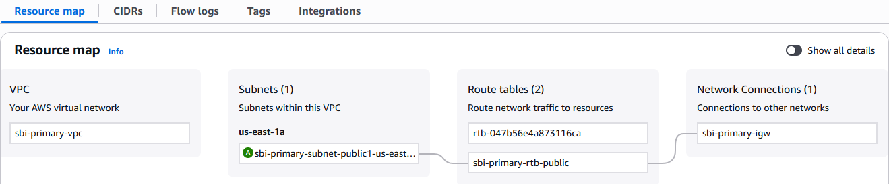

SBI-SECONDARY

* Go to <https://aws.amazon.com>.
* Sign into console home navigate to VPC.
* Click on create VPC.
* Resources to create : VPC and more
* Name : sbi-secondary
* Ipv4 CIDR block : 10.60.0.0/16
* No of availability zones :1
* No of private subnets : 0
* No of public subnets : 1
* NAT Gateway : None
* VPC endpoints : None
* Create VPC

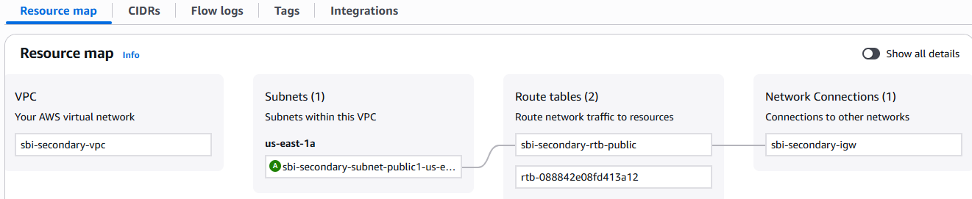

STEP-2 : Create security group .

SBI-PRIMARY-SG

* Go to security group.
* Name : sbi-primary-nsg
* Select vpc : sbi-primary-vpc
* Add inbound rules .

\*Type : SSH

\*Source : enter sbi-secondary-vpc address 10.60.0.0/16

* Then click on create security group.

SBI-SECONDARY-SG

* Go to security group.
* Name : sbi-primary-nsg
* Select vpc : sbi-primary-vpc
* Add inbound rules .

\*Type : SSH

\*Source : enter sbi-primary-vpc address 10.50.0.0/16

* Then click on create security group.



STEP-3 : Create Peering Connection.

* Go to primary Vpc under vpc dashboard peering connection option is there click on it.
* The peering connection page is open then click on create peering connection.
* Name : vpc-peer-01
* Vpc id requester : sbi-primary-vpc
* Vpc id accepter : sbi-secondary-vpc
* Then click on create peering connection.
* Go to Route table then click on sbi-primary-rtb-public the page is open.
* Click on edit routes and add route

\*Destination - address of sbi-secondary-vpc.

\*Target – Peering connection and id

* Again go to Route table then click on sbi-secondary-rtb-public the page is open.
* Click on edit routes and add route

\*Destination - address of sbi-secondary-vpc.

\*Target – Peering connection and id

